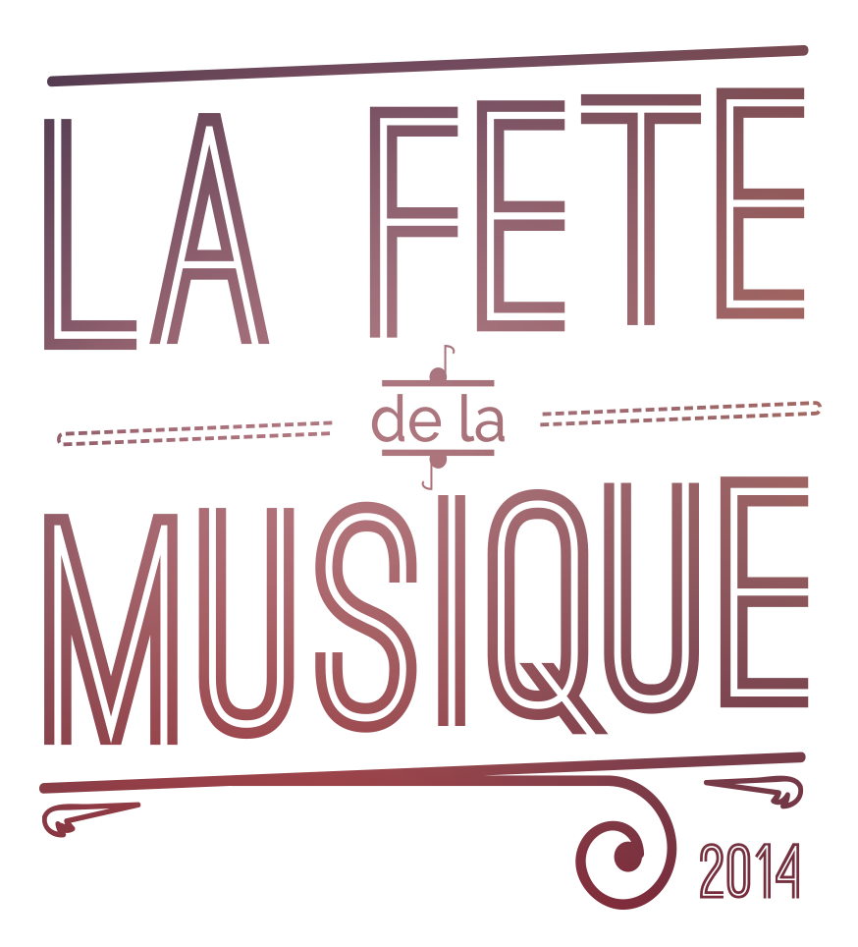
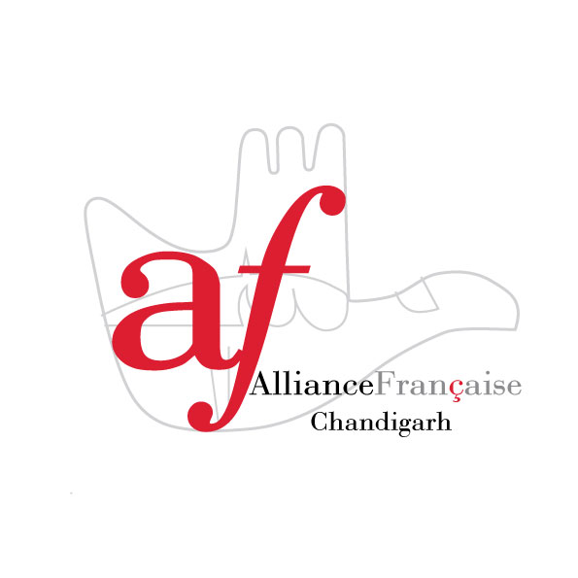


REGISTRATION FORM
FOR « LA FETE DE LA MUSIQUE 2014 »

Name of the band :

Name(s) of the member(s) :

Title of the Song/performance :

Type of performance (music, song, dance, french, penjabi…) :

Instrument(s) used :

Technical needs :

Contact :
Mail : …………………………………………………………………………
…………………………………………………………………………………
Phone Number : ……………………………………………………………

For any enquiries : Laure Guyot : 9646655339
Email : culture.chandigarh@afindia.org

