Fete du Court métrage – francophonie week
SATURDAY 7 PM - garden of afc
A SHORT INTRODUCTION

VICIOUS CYCLE
Director: Michael Marczewski
2017 / 03mn
Synopsis: Small autonomous robots are activated. A well-run machine. What happens when the pace picks up?

GATEAU GATO
Director: Alexandre Dubosc
2018 /01mn
Synopsis: Domestic "cake" from the Felidae family

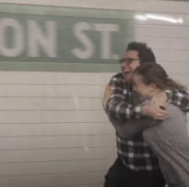
SUBWAY IDIOT 2
Director: Colin Elzie
2016 /01mn
Synopsis: An idiot who runs along the subway trains falls in love...

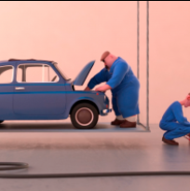
VOLTIGE
Director: Léo Brunel
2017 /01mn
Synopsis: Two mechanics are quietly ending their working day when an unexpected event forces them to turn into trapeze artists...

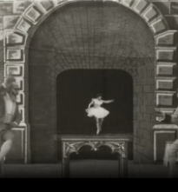
LA DANSEUSE MICROSCOPIQUE
Director: Georges Méliès
1902 /03mn
Synopsis: A magician conjures up a tiny lady who begins to perform a series of pretty steps...

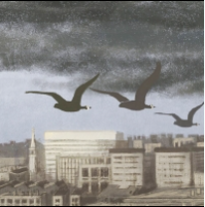
AUTUMN
Director: Sofia Gutman
2019 / 01 mn
Synopsis: It's autumn, the birds are migrating to warmer lands. In the gray streets of Paris, illegal immigrants sell shoes. Winter is coming.

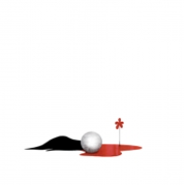
HOW TO PAINT YOUR RAINBOW
Director: Erick Oh
2018 /01mn
Synopsis : A man dies and a red flower blooms. Then come the colors orange, yellow, green, blue and purple which come into play and combine to become a sublime beautiful rainbow.

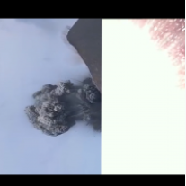
CONCATENATION
Director: Donato Sansone
2020 /01mn
Synopsis : A destructive sequence with infinite consequences.

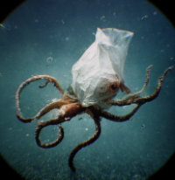
PLSTC
Director: Laen Sanches
2022 /01mn
Synopsis: You will never look at plastic the same way again.

FREED WOMEN
In sport, in ambitions or even in sexuality... Being a woman means encountering obstacles and in this program there are so many personalities who show us how to overcome sometimes complex situations and assert our freedoms. Meet these Affranchies, who show boldness and independence! These 6 short films (3 fictions, 2 animations and 1 documentary) are all made by women. Cycle time: 91 mins.
